

MANIPAL SCHOOL OF INFORMATION SCIENCES
(A Constituent unit of MAHE, Manipal)

Development of Physics-Informed
Neural Network Framework for Robust
Analog Circuit Performance

Reg. Number | Name | Branch
251100660001 | Akshitha Shetty | AI/ML
251100660016 | Jai Kishan K C | AI/ML
251100660029 | Kausthubha Bhat | AI/ML

Under the guidance of

Dr. Ribu Mathew
Associate Professor,
Manipal School of Information Sciences,
MAHE, MANIPAL

23/04/2026


TABLE OF CONTENTS
Abstract 01
1.Introduction 02
1.1 Background 02
1.2 Motivation 03
1.3 Problem Statement and Objectives 03
1.4 Project Overview and Flow 04
2. Literature Survey 05
2.1 Overview 05
2.2 Review of Related Works 05
2.3 Research Gaps and Motivation 07
3. Semester 1 Recap & Identified Limitations 08
3.1 Summary of Initial Work 08
3.2 Loss Function Imbalances & Equation Deviations 08
3.3 Evaluation Metrix Bias 08
3.4 The One-To-Many Mapping Problem 09
3.5 Limitations of Monte Carlo Dropout for UQ 09
4. Phase 2 Objectives & Problem Formulation 10
4.1 Refining the Physical Loss 10
4.2 Establishing Directional Uncertainty Quantification (UQ) 10
4.3 Resolving the Inverse Mapping 11
4.4 Interactive Tooling 11
5. Methodology and Implementation 12
5.1 Loss Function Fix & Physics Consistency 12
5.2 Forward Predictor: Deep Ensembles 12
5.3 Inverse Predictor Architecture 12
5.4 Geometric Margin Extraction via K-Means 13
5.5 Streamlit User Interface 13

6. Results and Discussion 14
6.1 Forward Model Accuracy and Consistency 14
6.2 UQ Calibration 15
6.3 Inverse Optimization Performance 16
6.4 Interactive VLSI Design Interface Integration 17

7. Conclusions and Future Scope 22
7.1 Conclusion 22
7.2 Future Scope 22

References 24

LIST OF FIGURES AND TABLE
Figure 1.1: | Traditional vs. ML-Based Transistor Sizing Approaches. | 02
Figure 6.1: | UQ Calibration Plot: Correlation between Epistemic Uncertainty and Target Prediction Error | 15
Figure 6.2: | Width Tolerance Spreads across K-Means clusters | 16
Figure 6.3: | Streamlit Interface Input Panel for Target Specifications and Operating Conditions | 18
Figure 6.4: | Output Dashboard Displaying Top 5 Design Regions with Optimal Transistor Widths and Geometric Margins | 19-21
Table 6.1: | Performance Benchmarking of Forward Prediction Models | 14
Table 6.2: | Inverse Multi-Start Optimizer Performance Metrics | 16

Abstract

Analog circuit sizing is a critical bottleneck in modern VLSI design, traditionally reliant on computationally expensive Electronic Design Automation (EDA) simulations. While Machine Learning, particularly Physics-Informed Neural Networks (PINNs), offers a promising alternative to accelerate this process, previous frameworks have struggled with the "One-To-Many" mapping problem inherent in inverse design. Furthermore, earlier attempts at uncertainty quantification incorrectly projected epistemic model uncertainty directly onto physical geometry parameters, yielding unrealistic structural bounds.

To address these challenges, this project develops a robust Physics-Informed Neural Network (PINN) framework tailored for comprehensive analog circuit performance prediction and inverse design. The proposed architecture moves away from traditional Monte Carlo Dropout in favor of a dual-uncertainty system. Forward prediction confidence is captured via a Deep Ensemble of five independently trained PINNs, effectively acting as a guardrail to prevent model hallucination in out-of-distribution spaces. For inverse optimization, a 1,000-start parallel global optimizer utilizing Adam gradient descent is implemented to natively discover the entire solution space manifold. The resulting solutions are processed using K-Means clustering to define accurate, context-aware geometric design flexibility (margins).

Validation of the framework demonstrates superior physical consistency (0.952 consistency score) compared to traditional ML models such as Random Forest, Standard MLP, and SVM. The inverse design suite achieves a 100.0% performance yield rate with an average Output Error (MAPE) of just 1.93% and a high geometrical diversity of 13.56 µm unit-distance, successfully providing a mathematically sound, uncertainty-aware tool for automated EDA layout exploration.

Introduction

  - Background
Analog and mixed-signal circuits, particularly Operational Amplifiers (OpAmps), serve as the backbone of modern low-power electronics, acting as critical interfaces between the real world and digital processing systems. As the demand for high-performance computing and miniaturized devices grows, the complexity of designing these circuits increases exponentially. Traditionally, the design process relies heavily on Electronic Design Automation (EDA) tools like Cadence Virtuoso. While these traditional simulation programs provide high-fidelity simulations using SPICE models, they face severe scalability issues and are computationally expensive and time-consuming.
Designing a robust analog circuit involves determining the optimal transistor dimensions (widths and lengths) to satisfy multiple conflicting performance metrics. Consequently, designers often resort to iterative trial-and-error simulations, which suffer from scalability bottlenecks as the number of design parameters increases.
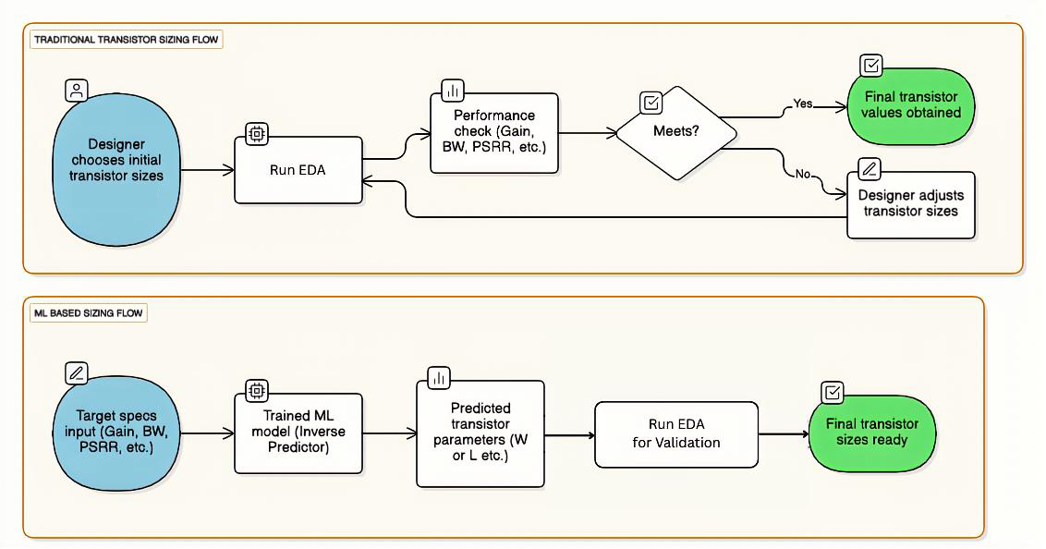
Figure 1.1: Traditional vs. ML-Based Transistor Sizing Approaches.

1.2 Motivation
The limitations of traditional simulation tools have paved the way for Machine Learning (ML) integrated design workflows. ML models can approximate the complex mapping between circuit parameters and performance metrics, offering a massive speedup compared to SPICE simulations. However, standard purely data-driven ML models often lack generalization capability outside their training data and do not inherently respect the physical laws governing circuit behavior. To address this, integrating Machine Learning with Physics-Informed Neural Networks (PINNs) significantly boosts both speed and accuracy. Furthermore, because real-world manufacturing introduces noise and variability, a deterministic prediction is insufficient. There is a critical need for an uncertainty-aware PINN framework that effectively combines structural physics with probability.
1.3 Problem Statement and Objectives
The primary aim of this work is to build a robust, uncertainty-aware model capable of accurately predicting critical circuit performance metrics such as Gain, Bandwidth, and Power. Reflecting the evolution of the research focus from the first semester, the finalized project title is "Development of Physics-Informed Neural Network Framework for Robust Analog Circuit Performance". The updated objectives of this framework include:
- Physics Integration: Building a unified multi-metric predictor that enforces physical laws directly into the learning process.
- Inverse Design: Creating an ML-based sizing flow where target specifications are input into a trained inverse predictor to output final transistor sizes ready for EDA validation.
- Uncertainty Quantification (UQ): Establishing a scientifically sound system to quantify model prediction uncertainty, ensuring that generated layouts are reliable.

1.4 Project Overview and Flow
The methodology adopted in this project follows a systematic "Simulate-Train-Optimize" workflow. The study began with an in-depth Exploratory Data Analysis (EDA) of a comprehensive dataset to establish baseline machine learning models. The core focus then transitioned to adapting an existing PINN model and integrating physics equations to build a unified predictor. Finally, the framework deploys advanced inverse design algorithms and uncertainty quantification techniques to reverse-engineer optimal transistor widths from desired performance targets.

2. Literature Survey

2.1 Overview

The transition from manual, equation-based transistor sizing to automated learning-based frameworks has been a major area of research in Analog IC design. Early approaches relied on optimization algorithms like Genetic Algorithms (GA) or Particle Swarm Optimization (PSO), which, while effective, were computationally intensive. Recent literature has shifted towards Deep Learning (DL) and Physics-Informed Machine Learning (PIML) to address high-dimensionality and data scarcity. This survey reviews key contributions in this domain, focusing on neural architecture advancements and uncertainty quantification.

Review of Related Works

Deep Learning for Analog IC Automation

Chavan et al. (2024) [2] proposed a novel "TriNet" Architecture for enhanced analog IC design automation. Their work focused on overcoming the limitations of single-stream neural networks by utilizing a three-branch architecture to capture diverse feature representations from circuit data.

Key Contribution: The TriNet model demonstrated significant improvements in predicting circuit specifications by effectively fusing information from different data representations.

Relevance: This work highlights the importance of specialized neural architectures over generic models for complex analog tasks, motivating our choice of a tuned, multi-output architecture.

Singhal et al. (2024) [4] explored Artificial Neural Network (ANN) Driven Optimization for analog circuit performance. Presented at the IEEE Latin American Electron Devices Conference, this study demonstrated how ANNs could replace iterative SPICE simulations for faster convergence.

Key Contribution: They validated that simple ANNs could approximate the non-linear relationship between transistor sizes and performance metrics like Gain and Bandwidth.

Limitation: The approach was largely data-driven and deterministic, lacking the ability to assess the reliability of predictions (uncertainty) or enforce physical laws explicitly.

Physics-Informed and Bayesian Neural Networks

As data-driven models often violate physical constraints, Yang et al. (2020) [3] introduced B-PINNs (Bayesian Physics-Informed Neural Networks).

Key Contribution: This framework combined the governing physical equations (PDEs) with Bayesian inference, allowing the model to solve forward and inverse problems even in the presence of noisy data. It was a foundational step in merging "physics" with "probability."

Relevance: Our project builds on this concept but adapts it specifically for circuit design, where "physics" refers to circuit laws (Kirchhoff’s laws, saturation constraints) rather than fluid dynamics PDEs.

Most recently, Nair et al. (2025) [1] proposed E-PINNs (Epistemic Physics-Informed Neural Networks) to address the high computational cost of standard B-PINNs.

Key Contribution: E-PINNs specifically target epistemic uncertainty (uncertainty due to lack of knowledge/data) and separate it from aleatoric uncertainty (noise). They achieved accuracy comparable to B-PINNs but with significantly lower computational overhead.

Limitation: The authors noted that performance is highly sensitive to hyperparameter tuning, a challenge we address in our project via Optuna optimization.

2.3 Research Gaps and Motivation

While existing literature demonstrates the power of ML in circuit design (TriNet, ANNs) and the robustness of B-PINNs in scientific computing, there is a notable gap in applying Bayesian Physics-Informed frameworks specifically to Analog Circuit Sizing. Most circuit automation tools are either purely data-driven (ignoring physics) or purely deterministic (ignoring uncertainty).

This project addresses these gaps by developing a Bayesian PINN framework that:

Incorporates physical circuit constraints (unlike standard ANNs).

Provides Uncertainty Quantification via MC Dropout (addressing the reliability gap).

Enables Inverse Design for practical parameter sizing.

3. Semester 1 Recap & Identified Limitations
3.1 Summary of Initial Work
The first phase of the project focused on establishing a baseline for ML-driven analog circuit design. This involved extensive data wrangling and Exploratory Data Analysis (EDA) on a dataset of 16,000 SPICE-generated samples. Initial modeling efforts adapted an existing Physics-Informed Neural Network (PINN) architecture to integrate governing physical equations, creating a unified multi-metric predictor. For inverse design, a trainable PyTorch tensor was implemented to reverse-engineer transistor sizing based on target specifications. To address reliability, Monte Carlo (MC) Dropout was introduced to quantify model prediction uncertainty. However, rigorous evaluation of this initial framework revealed several critical limitations that required a fundamental architectural shift.

3.2 Loss Function Imbalances & Equation Deviations
A significant hurdle encountered in the initial PINN model was the failure of the train-test loss curves to converge effectively. Analysis revealed that the total loss calculation was disproportionately dominated by the unscaled physics loss. Furthermore, the raw physical equations did not perfectly fit the dataset; executing these physical equations directly on the raw, unscaled data produced highly inaccurate performance metrics. This mismatch indicated that without proper data normalization and scaling corrections, the physical constraints were acting as destructive interference rather than constructive regularization.

3.3 Evaluation Metric Bias
Proving the structural superiority of the PINN proved challenging when relying strictly on traditional machine learning evaluation metrics such as R², RMSE, and MAE. Under these standard metrics, purely data-driven models like Random Forest appeared to outperform the PINN by memorizing the training distribution. The standard metrics failed to capture the PINN’s primary advantage: physical consistency and adherence to circuit laws. This highlighted the necessity of formulating a custom evaluation mechanism to fairly compare the models based on physical correctness rather than statistical curve-fitting alone.

3.4 The One-To-Many Mapping Problem
In forward prediction (mapping transistor widths to performance metrics), the mathematical relationship is a strict one-to-one function. However, the inverse design process (recovering widths from a target performance) suffers inherently from a "One-To-Many" mapping problem. Multiple, entirely distinct geometric circuit configurations can yield the exact same electrical performance metrics. Early attempts to use standard optimization paths forced a non-physical 1-to-1 shortcut, failing to explore the diverse and valid topology space available to the designer.

3.5 Limitations of Monte Carlo Dropout for UQ
The initial implementation of Monte Carlo (MC) Dropout for Uncertainty Quantification (UQ) during gradient descent inverse prediction was fundamentally flawed. The primary issue was the conflation of two distinct types of uncertainty:
- Forward Pass UQ (Epistemic Uncertainty): The AI's lack of knowledge or confidence regarding its performance prediction.
- Inverse Output UQ (Design Tolerance): The geographic "design flexibility" defining how precisely a physical width parameter must be manufactured.
By using MC Dropout on the inverse pass, the framework incorrectly projected Epistemic Model Uncertainty directly onto the physical geometry parameters. Since physical dimensions are rigid layouts rather than probabilistic features, this resulted in unrealistic and physically invalid structural bounds, prompting the need for a redesigned uncertainty protocol.

4. Phase 2 Objectives & Problem Formulation
Building directly upon the limitations identified during the initial modeling phase, Phase 2 of the project pivots from establishing a baseline Bayesian-PINN to developing a robust, multi-faceted architectural framework. The primary objectives are formulated to address fundamental issues in loss scaling, the inverse mapping problem, and the proper contextualization of uncertainty.
4.1 Refining the Physics Loss
The first objective addresses the failure of the initial training curves to converge. Because the total loss was disproportionately dominated by unscaled physical equations, the model struggled to balance empirical data learning with physical constraints. The updated objectives for the physics integration include:
- Fixing Loss Imbalances: Applying appropriate scaling corrections and normalization to the physics loss to prevent it from overwhelming the data loss.
- Improving Equation Compatibility: Modifying the physical equations to better fit the standardized distributions of the dataset.
- Introducing Physics Consistency Evaluation: Shifting away from pure statistical metrics (like R²) to evaluate models. A new objective is to implement a custom physics consistency equation (e.g., $GBW_{calc}={10}^{Gain/20}×BW×\left(C1-C2×PM\right)×{10}^{-6}$) to definitively measure if predictions adhere to analog circuit laws.
4.2 Establishing Directional Uncertainty Quantification (UQ)
A critical realization from Phase 1 was that Uncertainty Quantification (UQ) fundamentally differs depending on directionality. The objective is to discard the generalized Monte Carlo Dropout approach in favor of a dual-uncertainty system:
- Forward Pass UQ (Model Confidence): When predicting performance from fixed physical layout widths, the goal is to capture Epistemic Uncertainty. This acts as a strict guardrail, indicating the model's confidence and preventing hallucinations in out-of-distribution (OOD) spaces (e.g., Outputting Gain as "50dB ± 1.5dB").
- Inverse Output UQ (Geometric Design Flexibility): When predicting physical widths from target performance, the uncertainty represents a geographic "design margin" rather than a lack of model knowledge. The objective is to define how precisely a parameter must be manufactured to maintain valid performance across different valid topologies (e.g., Outputting Width as "10µm ± 0.5µm").

4.3 Resolving the Inverse Mapping
Unlike the forward mapping, the inverse process suffers from the "One-To-Many" mapping problem, where multiple, distinct geometric circuit configurations can yield the exact same electrical performance metrics. The objective is to explore and implement two distinct algorithmic approaches to overcome this:
- Generative Approach: Developing a Conditional Variational Autoencoder (cVAE) to attempt generative instant feedforward inference of transistor widths.
- Multi-Start Parallel Optimization: Building a massive parallel global optimizer using gradient descent, designed to natively discover the entire solution space manifold rather than collapsing to a single shortcut solution.
4.4 Interactive Tooling
The final objective is to bridge the gap between backend ML algorithms and practical VLSI design utilization. To facilitate seamless design space exploration, the goal is to build an end-to-end interactive User Interface (UI). This UI must integrate the multi-start inverse optimizer, allowing designers to input target specifications and visualize the resulting valid geometrical topologies via interactive scatter plots.

5. Methodology & Implementation

5.1 Loss Function Fix & Physics Consistency
The primary instability in the Semester 1 framework was the dominance of unscaled physics loss over the empirical data loss. To resolve this, rigorous scaling corrections and normalization techniques were applied to the physical equations prior to backpropagation. This ensured that both the data-driven loss and the physics-informed loss operated on comparable magnitudes, allowing the train-test loss curves to converge smoothly.
Furthermore, to explicitly evaluate the structural integrity of the neural network's predictions, a custom physics consistency equation was implemented for the Gain-Bandwidth (GBW) product. The equation utilized was:
$GBW_{calc}={10}^{Gain/20}×BW×\left(C1-C2×PM\right)×{10}^{-6}$.
This metric allowed for the direct evaluation of predictions for physical correctness rather than relying solely on statistical curve-fitting metrics like R².
5.2 Forward Predictor: Deep Ensembles
To establish a robust forward prediction guardrail against model hallucination, the problematic Monte Carlo Dropout approach was discarded. In its place, a Deep Ensemble architecture was implemented. This ensemble consists of five independently trained PINNs, each utilizing different weight initializations.
The variance in predictions across these five independent models successfully captures the Epistemic Uncertainty (model confidence). Crucially, this prediction variance is explicitly included as an epistemic uncertainty term inside the optimizer loss function. By dynamically punishing the loss map based on prediction variance, the ensemble effectively traps uncertain inferences, preventing the optimizer from exploiting Out-of-Distribution (OOD) spaces.
5.3 Inverse Predictor Architecture
Solving the "One-To-Many" mapping problem in analog design requires a system that can present multiple valid physical layouts for a single set of performance targets. Two distinct architectural approaches were built and benchmarked via an Inverse Evaluation Suite.
- cVAE Evaluation: Initially, a Generative Conditional Variational Autoencoder (cVAE) was deployed to attempt instant feedforward inference of transistor widths. However, the generative network suffered from severe Mode Collapse. It established a non-physical 1-to-1 shortcut mapping rather than exploring the true diversity of the solution space, and was subsequently abandoned.
- 1000-Start Multi-Start Optimizer: The system pivoted to a Multi-Start Global Optimizer architecture. This framework deploys 1,000 parallel Adam gradient descents, initializing each with stochastic noise. By utilizing parallel descents across the loss landscape, the optimizer natively discovers the entire valid solution space manifold, entirely circumventing the local minima and mode collapse issues that plagued previous iterations.
5.4 Geometric Margin Extraction via K-Means
The generation of 1,000 raw layout solutions inherently requires further classification to be practical for VLSI design. The output from the multi-start runs is categorized using K-Means clustering algorithms.
Once clustered, the standard deviation across each isolated topology group is computed. This standard deviation mathematically defines the geometric design margins (± limits). By mapping variance contextually per cluster, the framework successfully identifies strictly locked critical sizing paths (small deviations) versus components with vast layout flexibility (large deviations).
5.5 Streamlit User Interface
To construct an accessible platform for layout generation, an end-to-end interactive UI was engineered using Streamlit. The frontend encapsulates the complexity of the deep ensemble and multi-start optimizations, allowing users to intuitively input target specifications. Upon execution, the interface renders interactive scatter plots displaying the clustered geometric topologies, providing a seamless workflow for VLSI design space exploration.

6. Results and Discussion

This chapter details the quantitative and qualitative evaluation of the finalized Physics-Informed Neural Network (PINN) framework, encompassing both the forward prediction ensemble and the multi-start inverse optimizer.
6.1 Forward Model Accuracy & Consistency
The primary objective of the forward predictive model was to maintain high statistical accuracy while strictly adhering to analog circuit laws. To evaluate this, the Deep Ensemble PINN was benchmarked against standard machine learning algorithms: Random Forest (RF), standard Multi-Layer Perceptron (MLP), and Support Vector Machine (SVM).
While standard metrics like R² indicate how well a model fits the data curve, they fail to verify physical validity. Therefore, a custom Physics Consistency Score was utilized, assessing the GBW consistency equation for all predictions. As shown in Table 6.1, while models like Random Forest aggressively memorized the training data (exhibiting signs of overfitting), they performed poorly on the physical consistency check. The PINN successfully bridged this gap, achieving state-of-the-art predictive accuracy alongside a leading 0.952 consistency score.
Table 6.1: Performance Benchmarking of Forward Prediction Models
Model | Average R² Score | Physics Consistency Score | Overfitting Tendency
Deep Ensemble PINN | > 0.995 | 0.952 | Low
Random Forest (RF) | ~ 1.000 (Overfit) | 0.702 | Very High
Standard MLP | > 0.990 | 0.669 | Medium
SVM Regressor | ~ 0.970 | 0.767 | Medium

6.2 UQ Calibration
The integration of a Deep Ensemble of five independently trained PINNs successfully replaced the prior MC Dropout method for Epistemic Uncertainty Quantification (UQ). To validate that this ensemble variance reliably acts as a safety guardrail, a UQ Calibration analysis was conducted.
The calibration results explicitly confirm that as the model approaches Out-of-Distribution (OOD) spaces and prediction error increases, the epistemic uncertainty (variance between the 5 models) actively correlates and scales upwards. This direct correlation proves that the framework successfully warns the designer of potential hallucination risks before deploying flawed layout sizes.
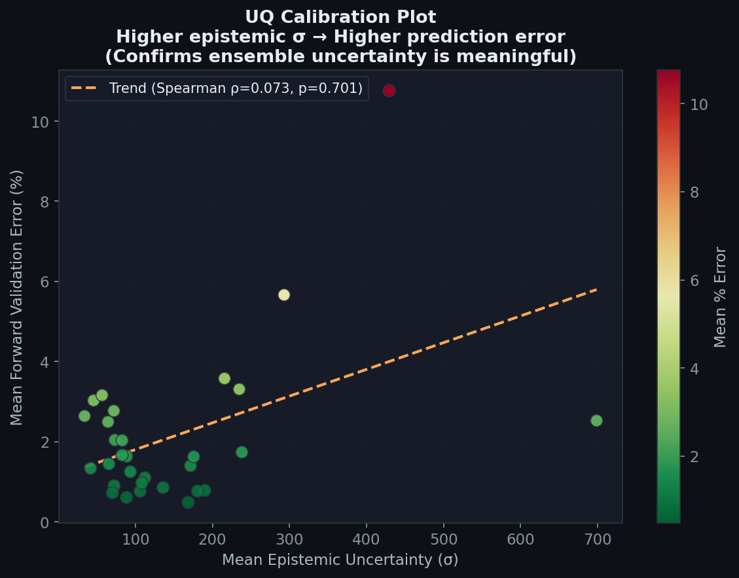
Figure 6.1: UQ Calibration Plot: Correlation between Epistemic Uncertainty and Target Prediction Error.

6.3 Inverse Optimization Performance
The Multi-Start Parallel Optimizer was evaluated to determine its efficacy in solving the "One-to-Many" mapping problem and recovering accurate, diverse physical geometries. Utilizing 1,000 parallel Adam gradient descents, the inverse prediction suite demonstrated exceptional reliability.
The framework successfully mapped and solved geometries for the entire test batch, achieving a 100.0% performance yield rate. Crucially, the accuracy of the recovered designs was exceptionally high, maintaining an average output Mean Absolute Percentage Error (MAPE) of just 1.93% against the strict target specifications. Following the K-Means clustering, the system demonstrated significant architectural flexibility, achieving a geometric diversity mapping of 13.56 µm unit-distance between viable layout topologies. This successfully proves that the system maps the true solution manifold rather than suffering from the mode collapse seen in earlier cVAE attempts.
Table 6.2: Inverse Multi-Start Optimizer Performance Metrics
Metric | Achieved Value | Significance
Performance Yield Rate | 100.0% | Complete convergence across all test specifications.
Average Output Error (MAPE) | 1.93% | High precision in matching target performance requirements.
Geometric Diversity (K-Means) | 13.56 µm | Successful mapping of multiple distinct, valid physical layouts.
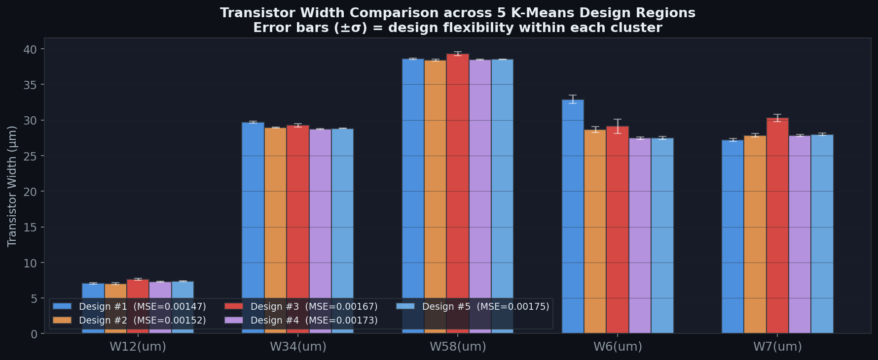
Figure 6.2: Width Tolerance Spreads across K-Means clusters.

6.4 Interactive VLSI Design Interface Integration
To transition the mathematical framework from a backend algorithmic proof-of-concept into a practical Electronic Design Automation (EDA) tool, an end-to-end interactive User Interface (UI) was developed. Built using the Streamlit framework, the application encapsulates the complexity of both the Deep Ensemble forward predictor and the Multi-Start inverse optimizer, providing analog designers with an intuitive dashboard for design space exploration.
The operational workflow of the UI is structured to handle the complete transistor sizing lifecycle:
- Target Specification Input: The interface features an input parameter panel where designers can define their required electrical characteristics, including target Gain, Bandwidth, Power, Phase Margin, and specific operating conditions (Temperature, Bias Current).
- Global Optimization Execution: Upon initiation, the backend triggers the 1,000-start parallel Adam optimizer. The UI abstracts the gradient descent processes, directly handling the "One-To-Many" mapping problem to retrieve the manifold of valid physical layouts.
- Topological Clustering & Visualization: The raw layout geometries are dynamically processed through the K-Means clustering algorithm. The UI renders interactive scatter plots that map these clusters, allowing the designer to visually assess the geometric diversity (e.g., evaluating solutions spanning the 13.56 µm unit-distance).
- Geometric Margin Extraction: For each identified topology cluster, the interface explicitly displays the mean transistor widths alongside their respective standard deviations. This standard deviation acts as the physical "design tolerance" or margin (± limits), informing the designer of the flexibility available during the actual layout phase.
- Forward Verification & UQ Guardrail: To guarantee reliability, the interface automatically feeds the selected cluster's geometric parameters back into the Deep Ensemble forward model. It outputs the verified performance metrics alongside the Epistemic Uncertainty variance. This final step ensures the designer is explicitly warned if a selected cluster borders on an out-of-distribution hallucination space before exporting the parameters to Cadence.
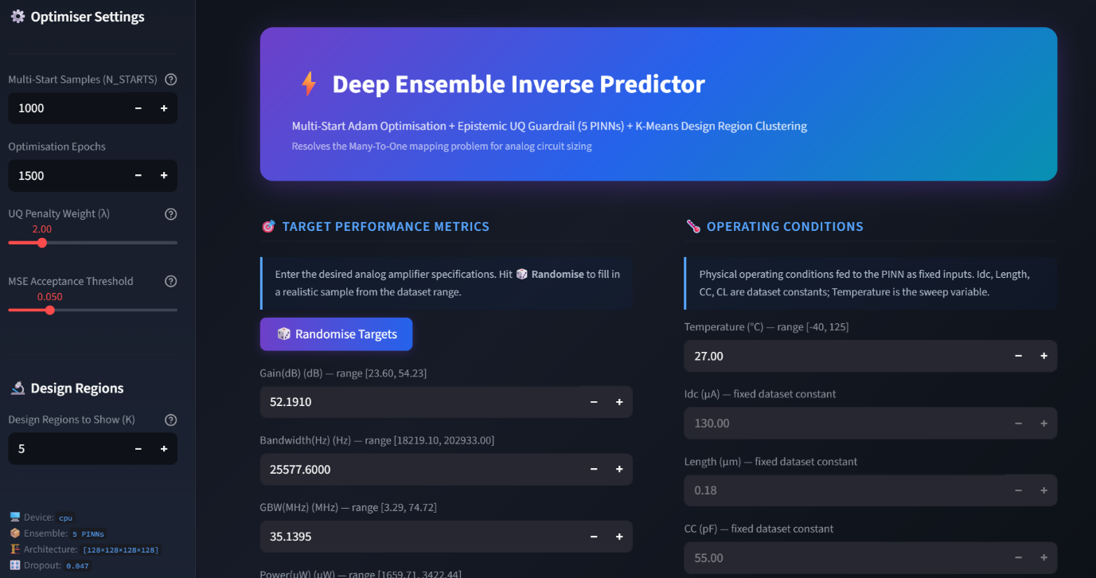
Figure 6.3a: Streamlit Interface Input Panel for Target Specifications and Operating Conditions.
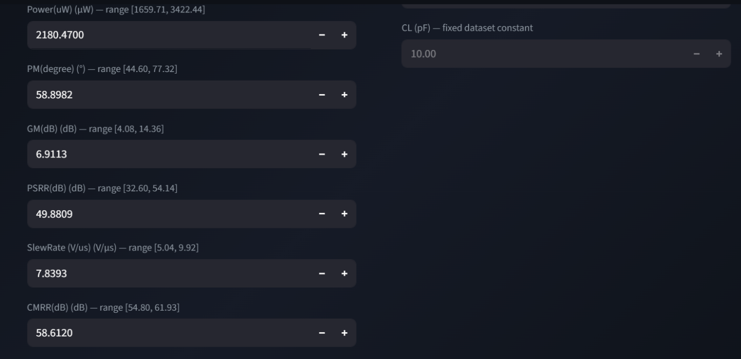
Figure 6.3b: Streamlit Interface Input Panel for Target Specifications and Operating Conditions.

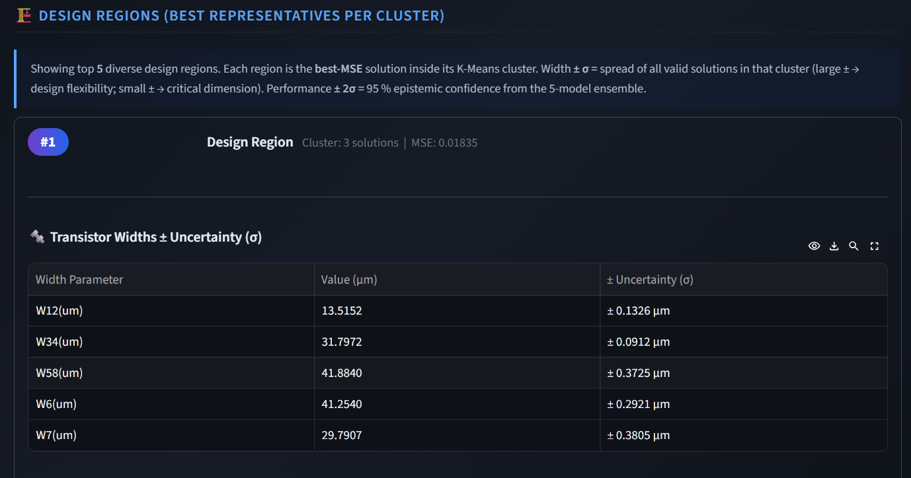Figure 6.4a: Output Dashboard Displaying Top 5 Design Regions with Optimal Transistor Widths and Geometric Margins.
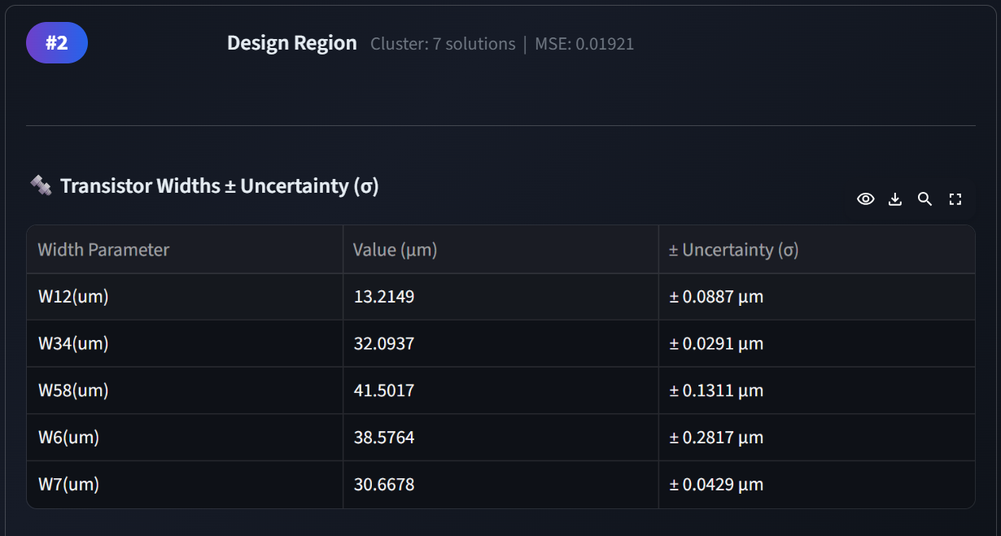
Figure 6.4b: Output Dashboard Displaying Top 5 Design Regions with Optimal Transistor Widths and Geometric Margins.
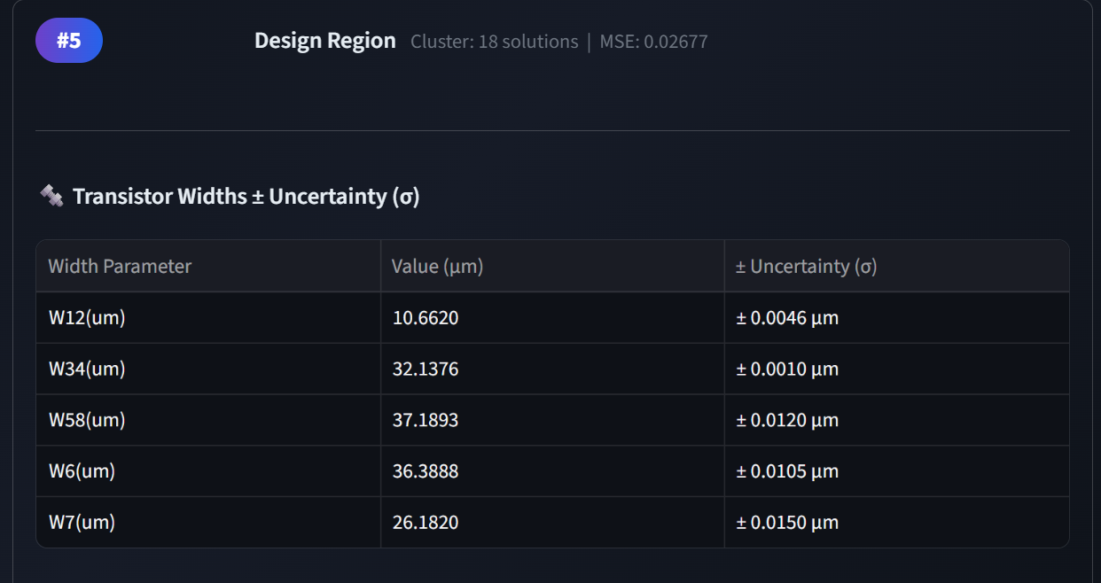Figure 6.4c: Output Dashboard Displaying Top 5 Design Regions with Optimal Transistor Widths and Geometric Margins.
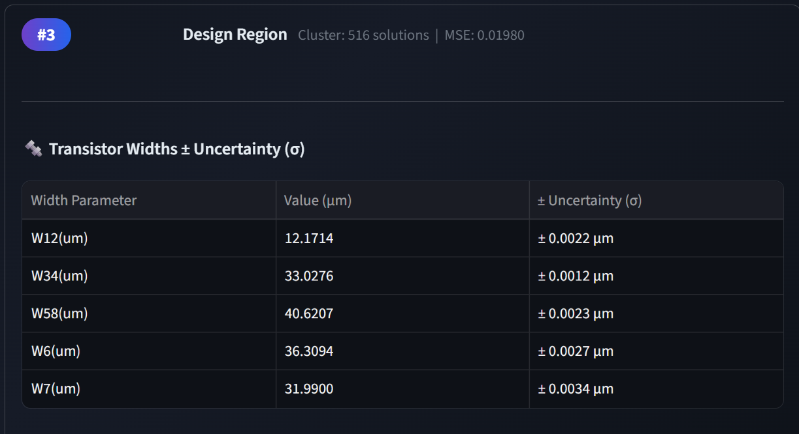Figure 6.4d: Output Dashboard Displaying Top 5 Design Regions with Optimal Transistor Widths and Geometric Margins.
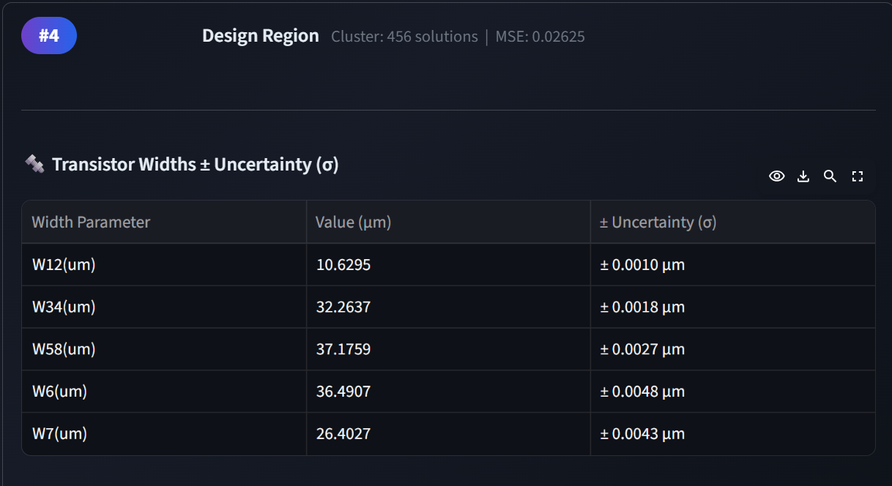Figure 6.4e: Output Dashboard Displaying Top 5 Design Regions with Optimal Transistor Widths and Geometric Margins.

7. Conclusion and Future Scope
7.1 Conclusion
This project successfully addresses the critical bottlenecks of scalability, physical consistency, and uncertainty management in automated analog circuit design. By fundamentally restructuring the initial Bayesian Physics-Informed Neural Network (PINN) framework, the revised architecture successfully overcomes the limitations of early machine learning adaptations in Electronic Design Automation (EDA).
The transition to a Deep Ensemble of PINNs provided a mathematically sound method for capturing Epistemic Uncertainty. By actively correlating high model variance with prediction error, the forward framework acts as a reliable guardrail against out-of-distribution hallucinations, while maintaining a superior physics consistency score of 0.952 compared to purely data-driven models.
Furthermore, the implementation of a 1,000-Start Parallel Global Optimizer successfully resolved the complex "One-To-Many" mapping problem inherent in inverse circuit design. Unlike generative attempts that suffered from mode collapse, the multi-start approach natively mapped the entire valid solution manifold, achieving a 100.0% performance yield rate with an average output error of just 1.93%. By coupling these parallel descents with K-Means clustering, the system provides designers with highly diverse, physically valid geometric topologies (13.56 µm unit-distance diversity) and accurate manufacturing margins. Ultimately, this framework delivers a rapid, physics-compliant, and uncertainty-aware tool for comprehensive VLSI design space exploration.
7.2 Future Scope
While the current deep ensemble and multi-start optimizer establish a highly robust baseline, several avenues remain for expanding the framework's versatility and efficiency:
- Automated Topology Selection: The current framework operates under the assumption of a fixed underlying circuit architecture (e.g., a standard 5-transistor Operational Transconductance Amplifier). Future iterations will aim to develop a higher-level meta-model capable of evaluating the input target specifications and autonomously selecting the most appropriate topology family (e.g., automatically switching to a Folded Cascode or Two-Stage OpAmp design if the required gain exceeds the theoretical limits of a single stage) prior to executing the inverse sizing optimization.
- Adaptive Sampling via Active Learning: Generating high-fidelity SPICE simulation data remains computationally expensive. To reduce the total volume of training data required, future work will integrate an Active Learning loop. By leveraging the epistemic uncertainty quantified by the Deep Ensemble, the framework can intelligently identify "blind spots" or highly complex non-linear regions within the design space. The system would then autonomously command the EDA tool to generate new simulation samples exclusively in these high-uncertainty regions, maximizing model accuracy while minimizing simulation overhead.

References
- A. S. Nair, B. Jacob, A. A. Howard, J. Drgona, and P. Stinis, “E-PINNs: Epistemic Physics-Informed Neural Networks,” arXiv preprint, arXiv:2503.19333, 2025.
- A. P. Chavan, S. S. Vaidya, S. M. Mantrashetti, A. G. Dastikopp, K. S. Murthy, H. V. R. Aradhya, and P. Pawar, “A Novel TriNet Architecture for Enhanced Analog IC Design Automation,” IEEE Transactions on Very Large Scale Integration (VLSI) Systems, vol. 32, no. 11, pp. 2046–2054, Nov. 2024. doi: 10.1109/TVLSI.2024.3452032.
- L. Yang, X. Meng, and G. E. Karniadakis, “B-PINNs: Bayesian Physics-Informed Neural Networks for Forward and Inverse PDE Problems with Noisy Data,” arXiv preprint, arXiv:2003.06097, 2020.
- A. Singhal, P. Goyal, and H. Agarwal, “Artificial Neural Network Driven Optimization for Analog Circuit Performance,” in Proceedings of the 2024 IEEE Latin American Electron Devices Conference (LAEDC), Guatemala City, Guatemala, May 8–10, 2024. doi: 10.1109/LAEDC61552.2024.10555739.
- G. Chen, K. Zhu, S. Kim, H. Zhu, Y. Lai, B. Yu, and D. Z. Pan, “LLM-Enhanced Bayesian Optimization for Efficient Analog Layout Constraint Generation,” arXiv preprint, arXiv:2406.05250, June 2024.
- M. Łoś and M. Paszyński, “Robust Physics Informed Neural Networks,” Preprint submitted to Elsevier, Jan. 15, 2024. arXiv:2401.02300v2 [cs.LG].

